Welcome to Mrs. Spruiell’s Class!!
Hello Students and Parents!
My name is Kathy Spruiell, and I will be your 4th grade teacher during the 2013-2014 school year! This year will be my 21st year in education. I have taught in the classroom for 10 years as a 6th, 5th, 4th, and 2nd grade teacher. The other 10 years I served as a math specialist and instructional math coach for grades K-5. My specialty is math instruction, and I dedicate some of my time to teaching other teachers how to enhance their math instruction. I am currently working towards my doctorate at Piedmont College.
I live in the Lilburn area and have a daughter who will also be in 4th grade at Arcado. My other daughter will be in 8th grade at Trickum Middle School. I have been married for 17 years to my wonderful husband. Our family is rounded out by our crazy little five pound Chihuahua named, Princess Sofia Jon Jones, or Sofie for short.
Please, please, please try to attend the Open House at Arcado between 1:00 – 4:00 pm, Friday, August 2, 2013. I can’t wait to meet you, and I have fun surprises for all my students and important information for all the parents.
I have shortened and modified the supply list, please note the list below. If you EVER have any questions, comments, or concerns, please email me at: Kathy_Spruiell@gwinnett.k12.ga.us . I also have a great amount of helpful information for you on my web site. You may cruise the site, or just go to the tab specifically made for our class. The website is fund at: www.mrsspruiellatschool.weebly.net .

See you soon!
Kathy Spruiell
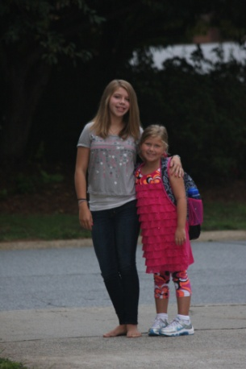

School Supplies for Mrs. Spruiell’s Class
2 Large Boxes of Tissues 1 Roll Paper Towels
1 Container of Cleansing Wipes or Baby Wipes 1 Package of Colored Pencils
2 packages Notebook Paper 36 #2 Pencils sharpened
1 Glue Stick 1 Highlighter (any color)
1 Three-ring 1” binder 2 Composition Books
1 8-pack Expo Dry-Erase Markers & Eraser 1 Bottle of Hand sanitizer
1 Yellow or Blue Plastic Pocket Folder (for Monday folder) 1 Pack of Copy Paper
1 Box of Gallon-sized Ziploc Bags 1 Box of washable markers
4 Sticky note packs 3” X 3”
Optional
1 pair of scissors (kid appropriate) and 1 pencil box or pouch

