Second Grade Weekly Homework Week 32 ©Created by Kathy Spruiell

Name_________________________________________Date_____________________________________
Topic | MONDAY | TUESDAY | WEDNESDAY | THURSDAY
Operations and Algebraic Thinking  2.OA | 825 + 246 = | 825 + 357 = | 825 + 579 = | 825 + 680 =
Operations and Algebraic Thinking  2.OA | 825 - 246 = | 825 - 357 = | 825 - 579 = | 825 - 680 =
Operations and Algebraic Thinking  2.OA | 9, 13, 17, 21 ____, ____, ____  What are the next 3 numbers in the pattern? | 21,25, 29,33, ___, ___, __  What is the pattern for the rule? | □ + 4 = 24  □ = ______ | 7 + 7 + 7 = 3 x ____
Geometry:  2.G | Which one doesn’t belong?  Why? | Draw a picture that shows 1/2. | Draw a figure with obtuse angles. | Which one doesn’t belong?  Why?
  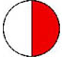 | 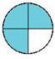 | 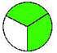
Measure-ment and Data:  TIME  2.MD.7 | 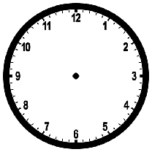Draw the time that is a 40 minutes later than 12:45? | Draw the time that is a 40 minutes earlier than 11:05? | What time do you read books? | Draw a clock that shows when you read books.
Measure-ment and Data:  MONEY  2.MD.8 | Tell three ways to make  $1.67 | Tell three ways to make $0.31 | Tell three ways to make $0.90 | Tell three ways to make $0.50
Measure-ment and Data:  LENGTH/  Graphing  2.MD.1-6  2.MD 9-10 | This house is 20 feet wide. How many feet is half as wide?   | The Guinea Pig is 10 inhces long. What amount is three times that long?  ________ inches  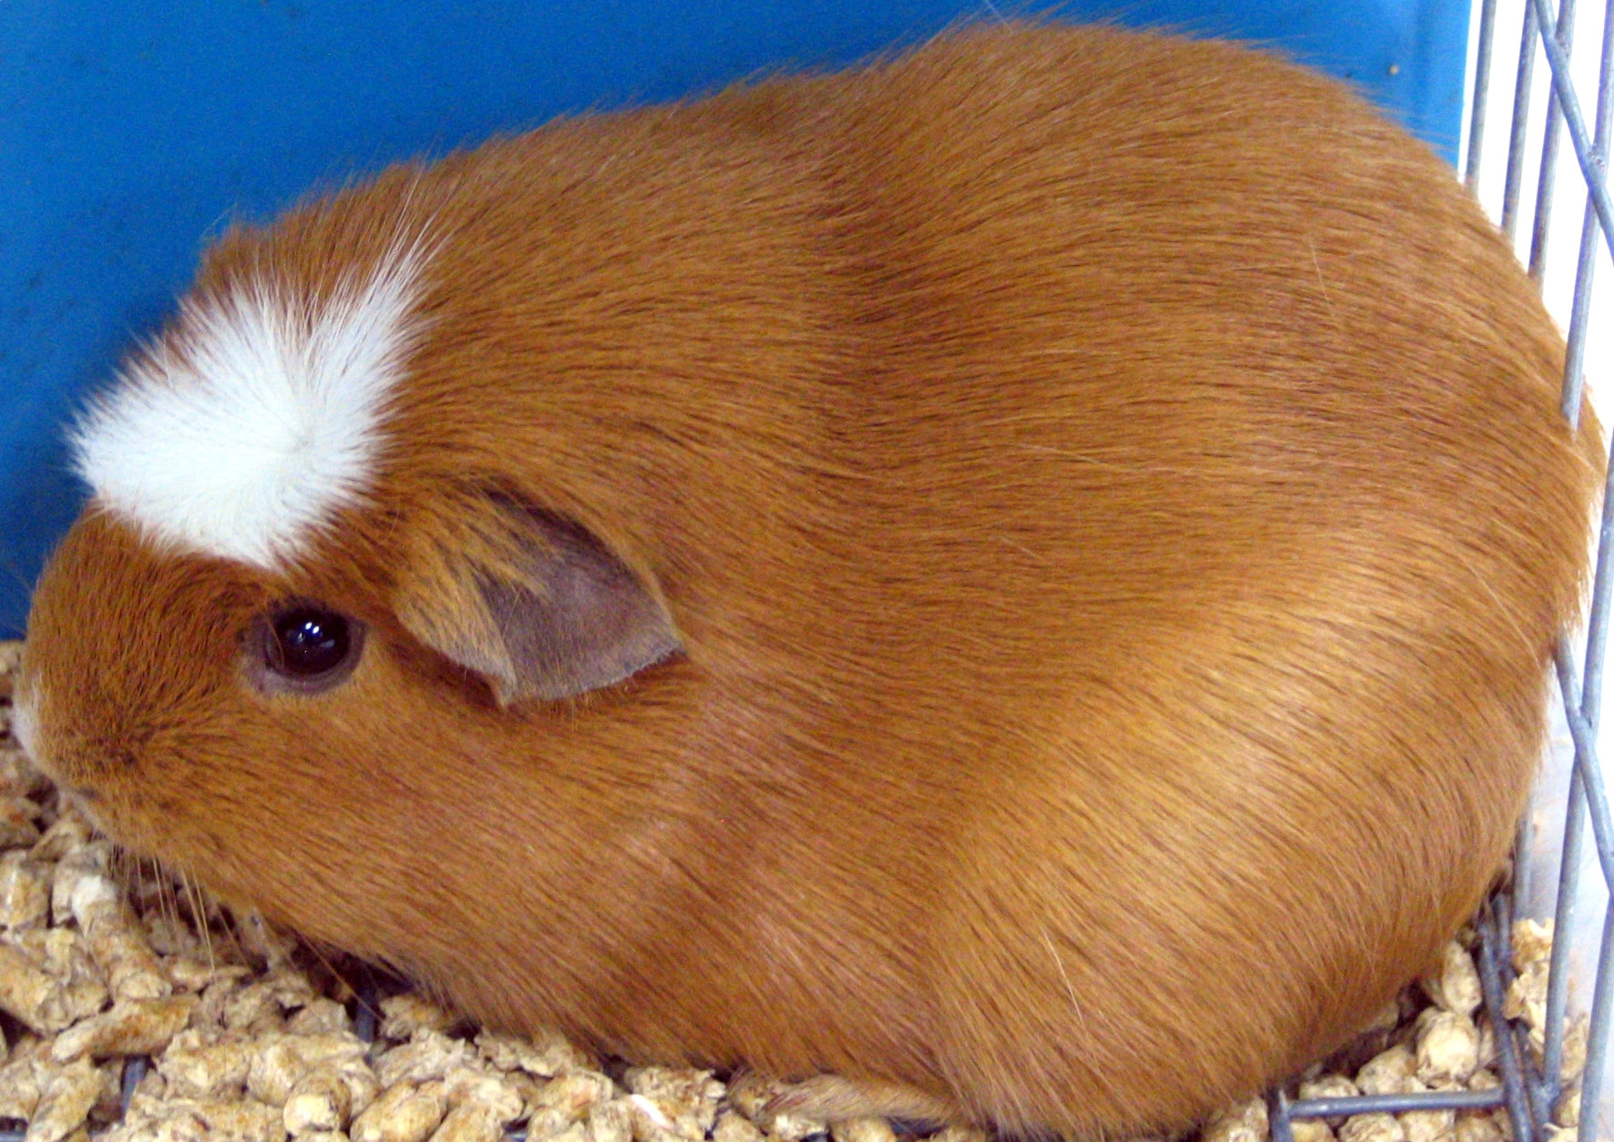 | Which amount on the line plot occurs the least?  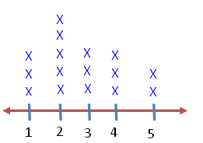 | How many fewer diamonds than hearts?  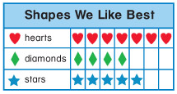
Number and Operations Base Ten:  2.NBT | Fill in all the missing numbers on the chart. | Circle the number 305.  What number is 7 tens and 2 ones more than 305? Circle it. | Circle the number 352.  What number is 2 tens and 8ones more than 352? Circle it. | Circle the number 373.  What number is 3 tens and 2 ones more than 373? Circle it.

301
400

