Second Grade Weekly Homework Week 29 ©Created by Kathy Spruiell

Name_________________________________________Date_____________________________________
Topic | MONDAY | TUESDAY | WEDNESDAY | THURSDAY
Operations and Algebraic Thinking  2.OA | 34 + 87 | 82 + 98 | 99  + 401 | 987 + 85
Operations and Algebraic Thinking  2.OA | 800 – 398 | 300 - 184 | 649  - 368 | 602 – 496
Operations and Algebraic Thinking  2.OA | Fill in the chart. | Fill in the chart. | Fill in the chart. | Fill in the chart.
  Wheels | Bicycle
  2 | 1
  4 | 2
  10
  Legs | People
  2 | 1
  10 | 5
  20
  Eggs | Carton
  12 | 1
  24
  36
  Legs | Spiders
  8 | 1
  16 | 2
  24
Geometry:  2.G | I am a quadrilateral. Draw me. | Draw a triangle. How many vertices does it have? | I am an obtuse angle. Draw me. | What type of angle is this?  _______________
Measure-ment and Data:  TIME  2.MD.7 | 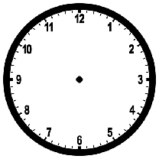Draw the time that is a 120 minutes later than 11:15? | Draw the time that is a 120 minutes earlier than 2:25? | What time do you eat brush your teeth? | Draw a clock that shows your dinner time.
Measure-ment and Data:  MONEY  2.MD.8 | How much money? ________  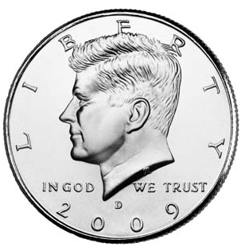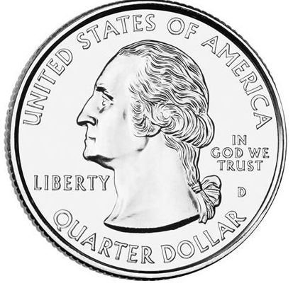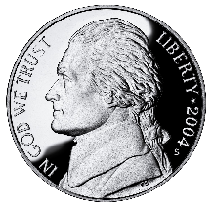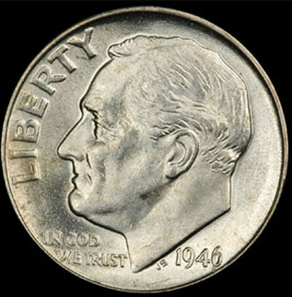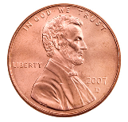  Show another way. | How much money? ______  Show another way. | How much money? _____  Show another way. | How much money? _____  Show another way.
Measure-ment and Data:  LENGTH/  Graphing  2.MD.1-6  2.MD 9-10 | This flagpole is 18 feet tall. How many feet is a half as tall?   | The dog is 12 inhces long. How many inches are twice that length?  ________ inches   | How many fewer blue than orange M &Ms?  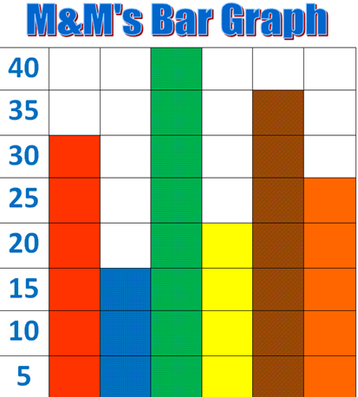  R Bl G Y Br O | Draw a number line from zero to four and label it. Show the halves between the numbers.
Number and Operations Base Ten:  2.NBT | Fill in all the missing numbers on the chart. | Circle the number 530.  What number is 4 tens and 1 ones less than 530? Circle it. | Circle the number 501.  What number is 3 tens and 2ones less than 501? Circle it. | Circle the number 466.  What number is 1 tens and 2 ones less than 466? Circle it.

451 |  |  |  |  |  |  |  |  | 460
491 |  |  |  |  |  |  |  |  | 500
541 |  |  |  |  |  |  |  |  | 550

