WATER AND WEATHER
- Label the different stages in the cycle. 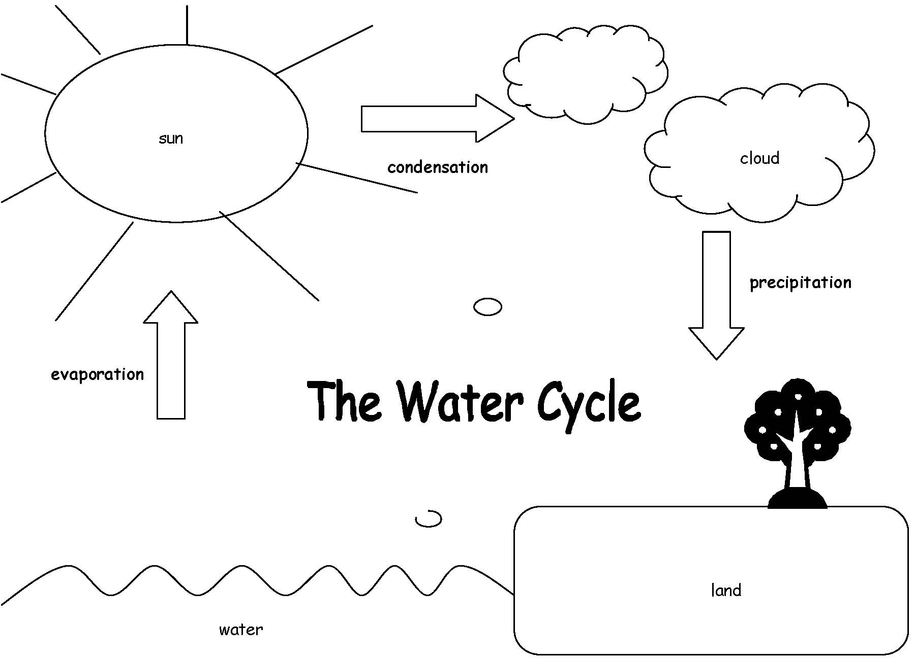

Define the terms below:
- Precipitation __________________________________________________
__________________________________________________________________
What are examples of precipitation? _____________
________________________________________________________
- Condensation____________________________________________________________________________________________________________________
- Evaporation_____________________________________________________________________________________________________________________
- The temperature at which water becomes water vapor is known as __________________.
- Vaporization is a phase change from a _________________ to a ___________________.
- Condensation is a phase change from a ____________________ to a __________________.
- What type of phase change is happening as water changes into ice? _______________________
- What type of phase change is happening as ice changes to water? _________________________
- What happens when ice reaches its melting point temperature? _____________________________________
_________________________________________________
11) What is the main difference between weather and climate? _____________________________________________________________
_______________________________________________________________________
- On a weather map, what do
12) How do clouds form? ________________________
________________________
13) Define the types of clouds below.
Cumulus _________________
________________________
Cirrus_________________
________________________
Cumulonimbus ___________
________________________
Stratus _________________
________________________

the following symbols represent?
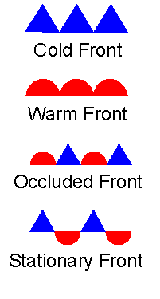
______________________
_____________________

_____________________

_____________________

Fill in the blanks.
14) A(n) __________________________ is used to measure temperature.
15) A(n) ______________________ is used to measure wind direction.
16) A(n) ______________________ is used to measure wind speed.
17) A(n) ______________________ is used to measure humidity.

EARTH CYCLES
18) Which of the following correctly completes the following sentence? Due to the tilt of the Earth's axis,
A. daylight in Texas lasts longer in December than in July.
B. the North and South Poles have the same seasons at the same time.
C. the Eastern and Western Hemispheres have opposite seasons.
D. certain regions on Earth can have non-stop daylight for six months of the year.

19) If you lived at point B in the diagram below, what time of day would it be? _______________________________
20) How do you know? ___________________________________________
_______________________________________________________________________
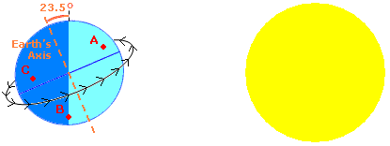
21) What season would A be experiencing right now? ___________
22) Explain your answer. ___________________________________
________________________________________________________

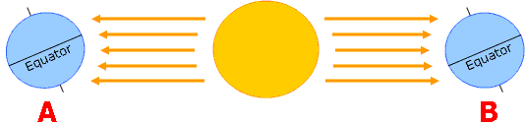

23) The figure above shows the Earth at two different positions in its orbit around the Sun. In which position would it be summer in the Northern Hemisphere?
A. position A B. position B
C. neither position A nor B D. both position A and B
24) Explain your answer. ___________________________________
________________________________________________________
25) Label the phases of the moon in the diagram below.
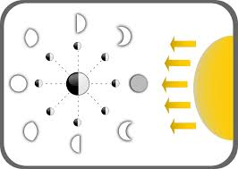
PLANETS
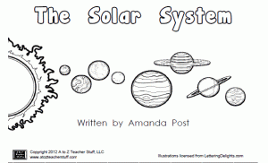
26) Label the solar system diagram.

27) Describe the inner planets. ___________________________
_____________________________________________________
28) Describe the outer planets. ___________________________
_____________________________________________________

29) What is the smallest planet in our solar system?
A. Mars B. Venus C. Mercury D. Earth
30) Which of the following is an inner planet of the Solar System?
A. Earth B. Uranus C. Jupiter D. Saturn
31) Which of the following planets is closest in size to Earth?
A. Mercury B. Neptune C. Venus D. Mars
32) Which of these is a lot larger than the Earth?
A. Mars B. Saturn C. Mercury D. Venus
33) Of the planets listed below, which is the largest?
A. Venus B. Mercury C. Earth D. Mars
34) What is the 7th planet from the Sun?
A. Neptune B. Saturn C. Uranus D. Jupiter

LIGHT AND SOUND
35) What is sound? _____________________________________
_____________________________________________________
36) Which of the following always causes a sound to change pitch?
A. changing the material that is making the vibration
B. changing the strength of the vibration
C. changing the speed of the vibration
D. none of these, there is no air in space.
37) Garrett has four strings that are the same thickness and are made of the same material. Garrett cuts the strings to different lengths and pulls them to the same tightness.
When he plucks the strings with his finger, which string will have the highest pitch?
A. They will all have the same pitch.
B. It is impossible to say.
C. The longest string will have the highest pitch.
D. The shortest string will have the highest pitch.
38) Jenny plucked a tight string. Which of the following best describes the way sound travels to Jenny's ears from the plucked string?
A. The air blows the sound to Jenny's ears.
B. Air waves carry the sound to Jenny's ears.
C. The vibrations of the string make the air vibrate which makes Jenny's ear drum vibrate.
D. The vibrations of the string make Jenny's ears vibrate.
39) Jenny plucked a tight string. If Jenny made the tight string shorter and then plucked it, what would happen to the sound?
A. The sound would be quieter. B. The pitch would be lower.
C. The pitch would be higher. D. The sound would be louder.
40) Which of the following statements is true?
A. Something must first produce a vibration before it can produce a sound.
B. Something cannot produce a sound if it also produces a vibration.
C. Something can produce a sound without producing a vibration.
D. Something must first produce a sound before it can produce a vibration.
41) Why do string instruments make sound?
A. They are made to recognize hand movement and then translate that into sound.
B. none of these
C. They are made so that the strings do not vibrate.
D. They are made so that the strings vibrate.
42) What are transparent objects? ________________________
_____________________________________________________
42) What are translucent objects? ________________________
_____________________________________________________
42) What are opaque objects? ___________________________
_____________________________________________________
43) Which of the following diagrams correctly shows how a convex lens refracts light?
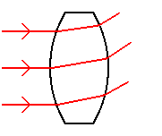 | 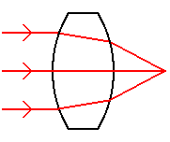
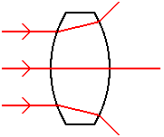 | 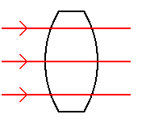
44) Which of the following diagrams correctly shows how a concave lens refracts light?
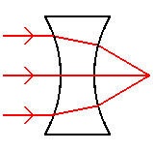 | 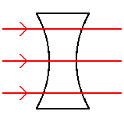
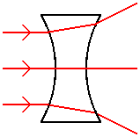 | 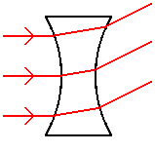
45) What are the colors that make up white light?
_____________________ _____________________
_____________________ _____________________
_____________________ _____________________
_____________________
46) Which of the following is used to bend different wavelengths of light to different degrees, separating it into its different colors?
A. air B. mirror C. metal D. prism
47) Which of the following surfaces reflects the most light?
A. tree trunk B. aluminum foil
C. concrete sidewalk D. yellow cloth

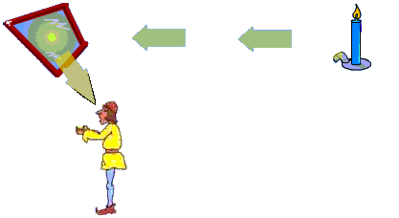
48) Which of the following shows the events in the order that they occur?

W. Light enters Joe's eye
X. Joe sees flame
Y. Candle flame gives off light
Z. Mirror reflects light

A. Y W Z X B. Z Y X W C. X W Z Y D. Y Z W X

49) In the picture below, a ray of light hits a mirror and changes direction. What is this "bouncing off" action called?
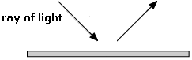
A. refraction B. condensation
C. reflection D. evaporation

SIMPLE MACHINES and FORCE AND MOTION
50) What do simple machines do? _____________________________
_______________________________________________________________________

Define the simple machine. | What problem would this machine help you solve?
Lever

Screw

Pulley

Inclined plane

Wedge

Wheel and axle

51) What does friction do to a moving object?
_______________________________________________________________________
52) What is inertia? ______________________________________________
_______________________________________________________________________
53) What is force? ________________________________________________
_______________________________________________________________________
54) What is the difference between a pull and a push?
______________________________________________________________________________________________________________________________________________
55) What is gravity? _____________________________________________
______________________________________________________________________

ECOSYSTEMS AND ADAPTATION

56) Define the terms below:

Ecosystems _____________________________________________________
____________________________________________________________________
Population _____________________________________________________
____________________________________________________________________
Community _____________________________________________________
____________________________________________________________________
Producer ________________________________________________________
____________________________________________________________________
Consumer _______________________________________________________
____________________________________________________________________
Decomposer ____________________________________________________
____________________________________________________________________
Hervibore _______________________________________________________
____________________________________________________________________
Carnivore _______________________________________________________
____________________________________________________________________
Omnivore _______________________________________________________
____________________________________________________________________

In a prairie ecosystem, birds feed on insects and snakes feed on birds. Imagine that humans began to hunt the birds in the area, and the bird population decreased.
57) How would the snake and insect populations be affected?
A. Snake population will go up because they don't have to compete for food, and insect population will go down because of lack of exercise.
B. Snake population will go down because of the smaller food supply, and insect population will go down because of disease.
C. Snake population will go down because the food supply is smaller, and insect population will go up because they have fewer predators.
D. Snake population will go up because they don't have to compete for food, and insect population will go up because they have fewer predators.

58) Food webs show how energy gets transferred among living things. A food web for a prairie ecosystem is shown below.
All plants and animals need energy in order to survive. Which of the following could survive without the energy from the Sun?
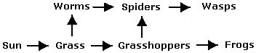
A. grass B. grasshoppers C. none of these D. frogs

59) How do adaptations help animals survive?
______________________________________________________________________________________________________________________________________________
60) Which of the following statements is true about adaptations?
I. A species can adapt over the course of many generations.
II. A single organism can adapt throughout its lifetime.
A. Both I and II B. I only
C. II only D. Neither I nor II

