Milestones Math Practice

- Mira is putting 100 colored pencils into boxes. Each box holds 16 pencils. How many boxes are needed to hold ALL of Mira’s pencils?

- Jordan picked 8 times as many strawberries as Aiden. If Aiden picked 56 strawberries, write an expression that can be used to find the number of strawberries Jordan picked.

- Draw a quadrilateral with all equal sides and 2 pairs of parallel sides. What is the name of this quadrilateral?

- Draw perpendicular lines.

- Which of the following figures has one line of symmetry?
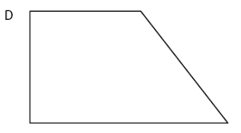
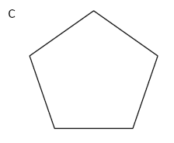
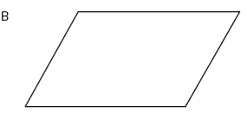
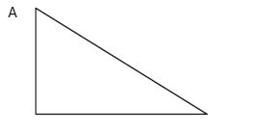

- The triangle below has two 30° angles. What is the missing angle? Classify the triangle by its sides and angles.
7 cm
7 cm
13 cm

- Which unit would be the MOST appropriate for measuring the weight of a backpack?
- Wanda drew a triangle that had two 45˚ angles and one 90˚ angle. What type of triangle did Wanda draw?
- Write the following number in expanded and word form.
32,705 Word form _______________________________
______________________________________________
Expanded form__________________________________
- Round 4,397 to the nearest hundred ________________
- Round 21,865 to the nearest ten thousand. ___________
- Round 79,412 to the nearest thousand. ______________
- Divide 358 ÷ 4

- Divide 916 ÷ 23
- If the model is one unit, which decimal and fraction is represented by the shaded part?
Fraction___________

Decimal___________

- 9 ¾ - 5 ¼ =
- 7 ¼ - 2 ¾ =
- 3 ⁴/₆ + 5 ¹/₆ =
- Compare the following fractions.
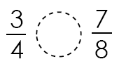
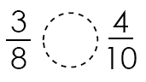
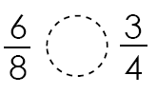

- Each person at a party will eat 3/8 of a pound of roast beef. There will be 5 people at the party. How many pounds of roast beef will be needed? Between what two whole numbers does your answer lie?

- 7 + 1 3 + 1 5 + 6
10 100 = 10 100 = 10 100 =

- Chris brought 5 liters of punch to a birthday party. John brought 4,000 milliliters of punch to the party. How many liters of punch did Chris and John bring to the party all together?

- Kim walked 2 kilometers on Saturday and 4 kilometers on Sunday. How many meters did Kim walk that weekend?

ounces | 16 | 32
pounds | 1 | 2 | 3 | 4
- Complete the table.

- 394 582 18 x 6 x 7 x 35

- Write a multiplication expression that describes the model below. ___________________________

- Compare the decimals using <, >, or =.
0.06 ______ 0.6 0.26 ______ 0.39

- The line plot below shows the number of miles different students in Ms. Frank’s class walk to school. Of all the students, Eric walks the longest distance to school and Layna walks the shortest distance to school. How many more miles does Eric walk to school than Layna?
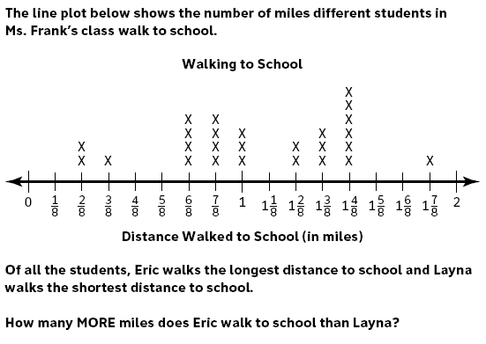
____________________________

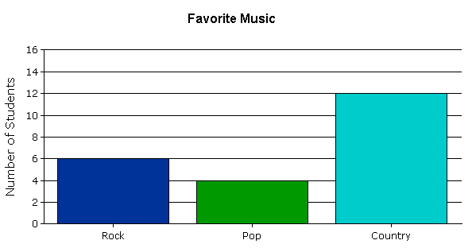
- Use the graph below. How many students like either rock or country music? ___________________________

- List the first 5 multiples of 6.
- List the factors of 24.
- Jack wants to put new carpet down in his living room. It is a square. Each side is 14 feet. How much carpet will Jack need to cover the floor?

- Mr. Johns bought 8 packages of hot dogs for a cook-out. The total cost of the hot dogs was $24.00. Which of the following number sentences could be used to determine the cost of one package of hot dogs?
  - $24.00 + 8 = c
  - $24.00 x 8 = c
  - $24.00 ÷ 8 = c
  - $24.00 - 8 = c
- There are 2,457 boxes of pencils. There are 13 schools in a town. Each school will get the same number of boxes. How many boxes will each school get?

- 360 ÷ 30 yields the same quotient as
  - 36 ÷ 3 c. 360 ÷ 3
  - 36 ÷ 12 d. 360 ÷ 12
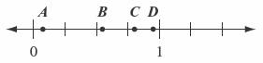
- Which point on the number line below best represents 0.8?

- Which decimal is LEAST? 0.19, 0.09, 0.9, 0.1
- Jimmy ate three slices of a twelve slice pizza. What fraction is equivalent to the fraction of the whole pizza that Jimmy ate?

- Jack painted a picture using three colors.
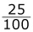
of the picture is green.
of the picture is blue.

The rest of the picture is purple.

Write a fraction that shows the part of Jack’s picture that is purple.

- Carlos has 72 toy cars. He wants to organize the cars into boxes. Each box can hold 8 cars. How many boxes will Carlos need?

- There were 75,631 people at a concert. What is that number rounded to the nearest ten thousand people?

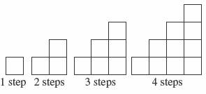
- The first four figures in a pattern are shown below.

If the pattern continues this way, how many blocks are needed to make 6 steps?

