Social Studies Milestones Review
Tribe | Region | Natural Resources | Food | Shelter
1.
Inuit
2. Kwakiutl
3.
Nez Perce
4.
Hopi
5. Seminole
6.
Pawnee

Explorer | Paying Country | Reason for Exploration | Where They Explored | Accomplishments
7. Christopher Columbus
8. Juan Ponce de Leon
9.
John Cabot
10. Vasco Nunez de Balboa
11.
Henry Hudson
12.
Jacques Cartier

13. What were the main industries of the New England Colonies? _____________________________________
_____________________________________________
14. What were the main industries of the Middle Colonies?______________________________________
_____________________________________________
15. What were the main industries of the Southern Colonies? _____________________________________
_____________________________________________
16. What is the difference between an indentured servant and a slave? ______________________________
______________________________________________________________________________________________
17. How were Native Americans important to the survival of the Plymouth Colony?___________________________
______________________________________________________________________________________________
18. Why was there often conflict between Native Americans and European explorers and settlers?
______________________________________________________________________________________________
19. What did King George III and the British Parliament do after the French and Indian War ended that upset the American colonists?______________________________
_____________________________________________________________________________________________
20. What does the slogan “no taxation without representation” mean?____________________________
______________________________________________________________________________________________
21. Describe the importance of the Battles of Lexington and Concord. ___________________________________
______________________________________________________________________________________________
22. What was the purpose of the Declaration of Independence? Who wrote it? ______________________
______________________________________________________________________________________________
23. Which battle was considered the “turning point” of the American Revolution? Why? ____________________
______________________________________________________________________________________________
24. What was the last major battle in the Revolutionary War? How did the Americans win? _________________
_____________________________________________________________________________________________________________________________________________
25. After the war, why did representatives meet at a Constitutional Convention in Philadelphia? ____________
______________________________________________________________________________________________
26. What is the purpose of the Bill of Rights?___________
______________________________________________________________________________________________
27. What are the responsibilities of the legislative branch?_______________________________________
__________________________________________________________________________________________
28. What are the responsibilities of the executive branch? _______________________________________________
______________________________________________________________________________________________
29. What are the responsibilities of the judicial branch?
______________________________________________________________________________________________
30. What are checks and balances? Why did the writers of the Constitution include them? _____________________
______________________________________________________________________________________________
31. What were the causes of the War of 1812? ________
______________________________________________________________________________________________
32. What was the purpose of the Lewis and Clark expedition? _____________________________________
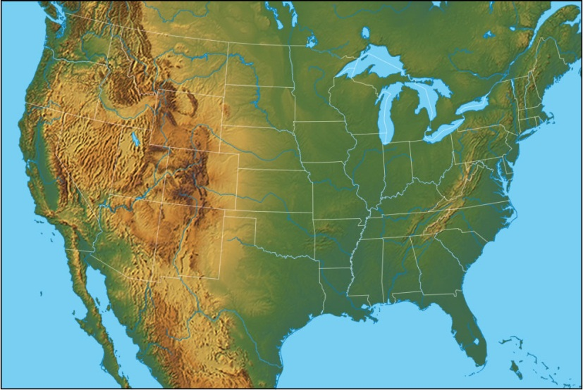
______________________________________________________________________________________________
G
33. What event led to population increase and statehood for California? ___________________________________
_______________________________________________
34. What was the effect of westward expansion on Native Americans? _____________________________________
______________________________________________________________________________________________
35. How did the invention of the steamboat, the locomotive, and the telegraph impact life in America?
_____________________________________________________________________________________________________________________________________________
36. How were Elizabeth Cady Stanton and Sojourner Truth important to the women’s suffrage movement?
_____________________________________________________________________________________________________________________________________________
37. How was Harriet Tubman related to the abolitionist movement? ____________________________________
______________________________________________________________________________________________
38. What is the significance of “We the People” from the Preamble of the U.S. Constitution? __________________
_____________________________________________________________________________________________
39. Give an example of a time you had to make a choice between two things. What did you choose? What was your opportunity cost? ___________________________
_____________________________________________________________________________________________________________________________________________
40. How did artisans in Colonial America practice specialization? __________________________________
______________________________________________________________________________________________
41. How does voluntary exchange benefit both buyers and sellers? _____________________________________
______________________________________________________________________________________________
42. How does supply and demand affect prices? _______
______________________________________________________________________________________________
_______________________________________________

_______________________________________________

A
Write the letter that matches each feature on the map.

43. _____Gulf of Mexico
44. _____St. Lawrence River
45. _____Great Lakes
46. _____Atlantic Coastal Plain
47. _____Great Plains
48. _____ Great Basin
49. _____Continental Divide
50. _____Death Valley

B
E
D
H
F
C

